**Software Design and Development Logbook**

**Stage 1:**

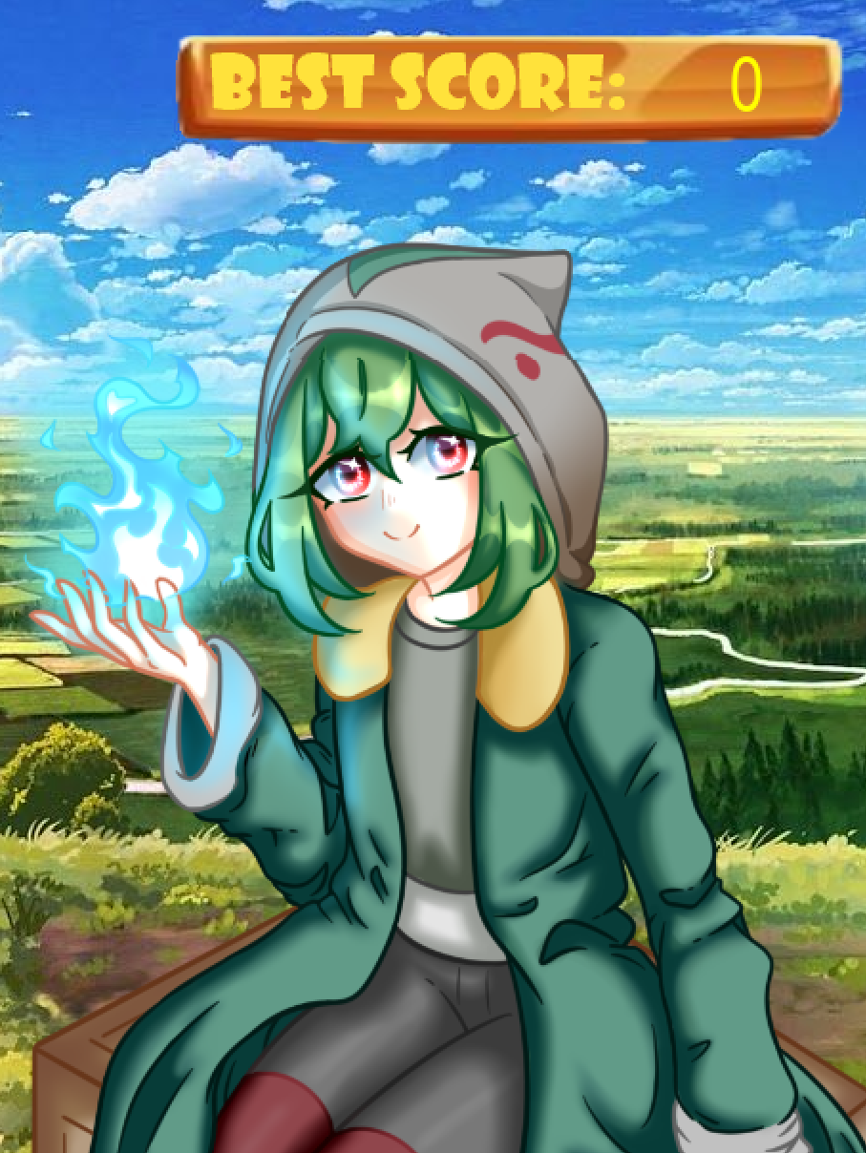This logbook is for the software design project. The reference is taken from the Russian fairy tale “About rejuvenating apples and living water”

The game is suitable for all ages. There is no age limit. The expected audience is people from 8 years old. Designed for solo players.

The player begins his journey on a forest path, playing as a girl with magical powers. As enemies, you will be attacked by slimes of various shapes and sizes. The main task of the game is to stay alive as long as possible and score more points by reaching the last level. Over time, the difficulty of the game increases and the enemies become faster and more maneuverable. There are objects on the map that do not allow enemies to pass, behind which you can hide and keep the defense more effective. Scoring is rewarded by unlocking weapon customization. When the life bar reaches zero, the game ends.

Required programs are:

Visual Studio Code (version 1.59 and higher)

Gantt chart:

**Logbook:**

Date: April 8 2022

Time: 5 hours

I thought about what kind of project I was going to do. After the last project, my skills have improved and I plan to do something much more difficult than last time. I already have some ideas about mechanics that I want to implement into my game.

Date: April 13 2022

Time: 1-2 hours

I got an idea for a game. Now I need to plan my work on it. If I work without interruption, I have about 4 months. 4 weeks of this is a vacation where I can work with double strength. I am sure that I will manage it during this time.

Date: April 28 2022

Time: 1 hour

After planning the project, I got to work. The name for the game has not yet been invented. First, I had to write the main loop of the game. This is the most boring part of the project. Luckily, I had a basic template. What a fine fellow I am that I do not delete old programs. I just had to adjust the speed of the game by setting the required number of FPS. Also, I need to add the required libraries. There were no problems at this stage since I had everything ready in advance. Next, I must make a game window.

Date: April 30 2022

Time: 1 hour

I have added the required libraries. But I ran into a problem. The “pygame” library didn't work. I tried 3 different ways to install it, but it still hasn't worked. The solution was simple - to stop and rest. The next day everything worked. Perhaps the solution to the problem was to restart the computer. I'm glad it worked out. Next, I made a game window. For the convenience of testing, I set the base colors. Next, I plan to make the movements of the player.

Date: May 3 2022

Time: 4 hours

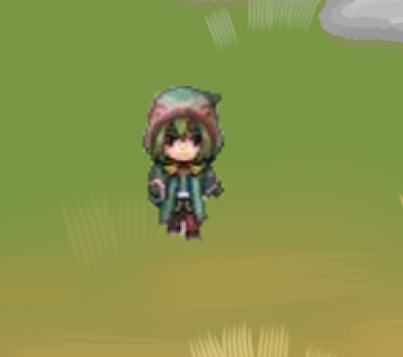 I spent most of the time in this step making an infinite field. There was a problem: due to the wrong code, when the player left the screen, he disappeared without a trace. This problem was solved by correcting the code. I'm glad it worked out pretty quickly. But I don't like that the player looks like a "cube". Between the stages I need to add a player sprite.

Date: May 10 2022

Time 9 hours

My second goal was to create an infinite field that the player could move around.

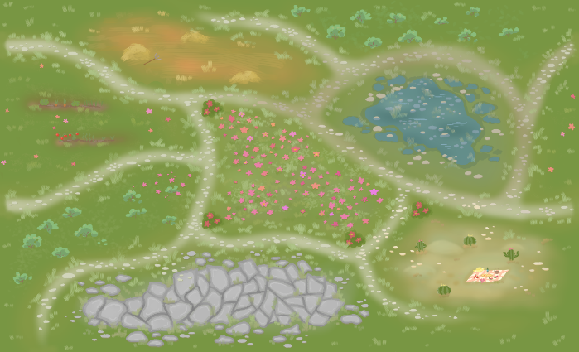The main problem was that the screen bezels are stationary, so to create the illusion of movement, it is important that the ground sprite move realistically under the player. I made a very smooth and pleasant movement that I'm happy with, but the field still needs some work because it's not infinite.

Date May 15 2022

Time 6 hours

Made an infinite field that spawns throughout the entire movement. Now the player is not limited in movement.

The next goal is to make enemies to make the game more interesting. There was an issue with the field's hitbox, causing parts of the field to overlap. I hope to resolve this issue as soon as possible.

Date: May 23 2022

Time: 10 hours

I added a player sprite. But it was taken from the Internet, so in the future I will replace it with my own. Also the issue with field’s hitbox is fixed too.

This stage was many times more difficult than all the previous ones. I added the enemies "slimes". I was very tired and needed a break of a couple of days. I investigated the "random" library. There were problems with setting random parameters. Slimes now move at different speeds. At the moment, slomes are harmless for the player. Plans to make a system of shooting and collisions. I am proud of my work.

Date: June 6 2021

Time: 4 hours

I made an slime and player collision system. Now, any slime can kill the player. I think it's too difficult. This will need to be fixed in the future.

To make the collisions more correct, I made the correct hitboxes.

A separate folder with sprites was made. The problem was to show the computer where this folder is. The "os" library helped me a lot. I also created a folder with sounds in advance.

Most of the time this stage took me to create the shooting. Problems with bullet size and hitboxes. There were also problems with the crash of the game after being hit by an asteroid. All bugs were fixed.

Next, I am planning to make the player HP.

Date: June 15 2022

Time: 5 hours

At this point, I add an HP of the character. It was simple enough and there were no problems. But the gameplay was boring, the player lacked complexity. To fix this, I decided to add difficulty levels. Because of them, the game found its goal. It was also decided to show the player how many points he got, and his best score so that he could compete with someone.

Not without a couple of errors in the code. I constantly forget to indicate from which library a particular command is taken. Everything was solved with the help of the Internet and various forums, where they willingly helped me. It's good that there are such kind people.

To make the game more enjoyable, I plan to add music and sounds to the game.

Date: July 8 2022

Time: 3 hours

Following a guide from the internet, I added music and fireball sounds. There were problems with the type of music files, but changing them, everything worked out. The stage was boring enough. But after this stage, the game changed. It now looks more like a full-fledged mini game. I am very happy about it.

The copied sprites make the game feel less unique. Next, I plan to draw sprites.

Date: July 14 2022

Time: 3 hours

I haven't started working with sprites yet.

I enjoyed my game for a long time. I tested all possible actions. No bugs were found. This makes me happy.

I will be making sprites soon.

Date: July 19 2022

Time: 1 hour

No sprites have been drawn yet. I'm a bad artist. I had to ask a friend for help, and she drew me the background of the game. The game becomes more beautiful.

I am facing the most important problem of the project - the name of the game. I need to come up with it as soon as possible.

Date: August 5 2022

Time: 3 hours

I added the HP and player sprites. Also made the animation of the loss. I really like it. Then all that remains is to test the game and identify subtle bugs.

**Stage 2:**

Flowchart:

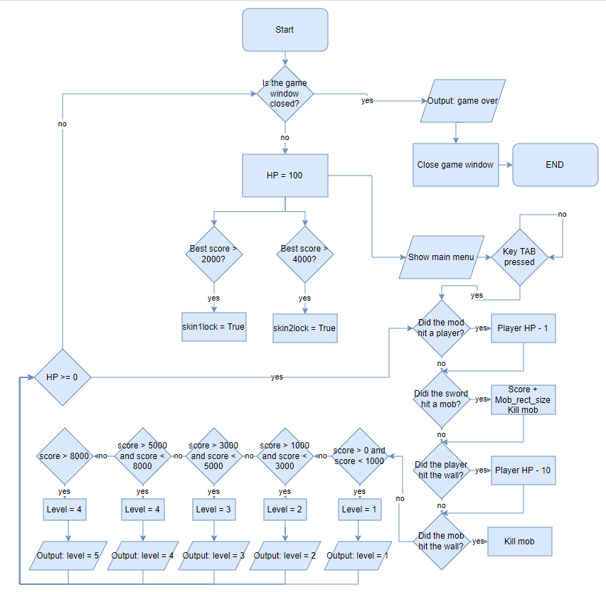

Structure chart: 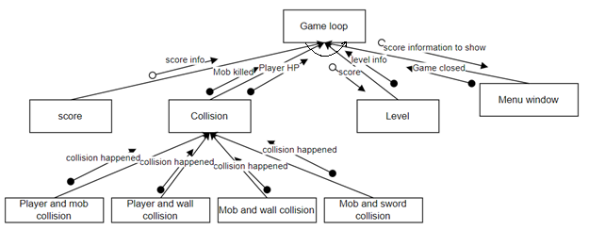

**Stage 3:**

[See GameNoel_v3.py file]

**Stage 4:**

**User manual:**

**System requirements:** x32 or x64 operating system.  
16mb RAM

90.0 mb Hardrive Space

Pentium processor at 90MHz or higher

Visual Studio Code and external files v1.59 or superior

Windows 7,8,10

**Installation guide:**

Installation guide: With the files received, open Visual Studio Code with whichever version you have installed and go to ‘File’ at the top-left of the VScode screen and click ‘Open Folder...’. Locate the GameNoel_v3 folder, click it and click 'Open'. Press CTRL+` to open terminal and then enter 'python GameNoel_v3.py' to the console line, then press ‘Enter’ button.

**Instructions for use of the program**

Start the game on your computer.

Everything is keyboard based. Use buttons: TAB - to start the game, E – to see controls, Q – to see skin settings screen, ESC – to exit the game.

On skin settings screen use 1, 2, 3, 4 buttons to choose the skin.

Use W, A, S, D to move and SPACE to shoot.

Goal of the game: to reach the 5th level and unlock all skins. How to reach it, described in the tutorial.

**Tutorial:**

When you start the program, you will see the main menu. To start the game press the button TAB. Other buttons are labelled.

The main goal of the game is to get to the 5th level. Then the game will be endless.

You start playing as a character in the middle of the field. Use the **W, A, S, D keys** to navigate the field. You are attacked by slimes, from which you need to defend yourself. If the slime hits you, you will **lose certain amount of HP**. Your task is to shoot them by releasing fireballs by **pressing the SPACE bar**. If a fireball hits a slime, it will explode and disappear, and you will be **awarded random number of points**. The received points and the level of the game can be seen at the top right of the screen. The longer you shoot down slimes, the more difficult the game becomes. The level of the game rises for every 2000 points earned, up to the 5th level. At each level, slimes become faster. Initially, the character has 100 HP. The amount of HP can be seen in the upper left corner of the screen. If the HP level drops to 0, the **game will end**. To prevent this, flasks will spawn on the map that **increase your HP**. There are also various objects on the map, upon contact with which **20 hp is lost** and the object is destroyed. If you shoot at an object, it will be destroyed and you will only **lose 5 hp**. Objects also kill slimes, but you will not get points for them. Objects can be used for defensive purposes. When the game ends, you are taken to the main menu, with the initial selection. For 2000 and 4000 earned points, skins for fireball are unlocked.

**Screens:**

Main menu:

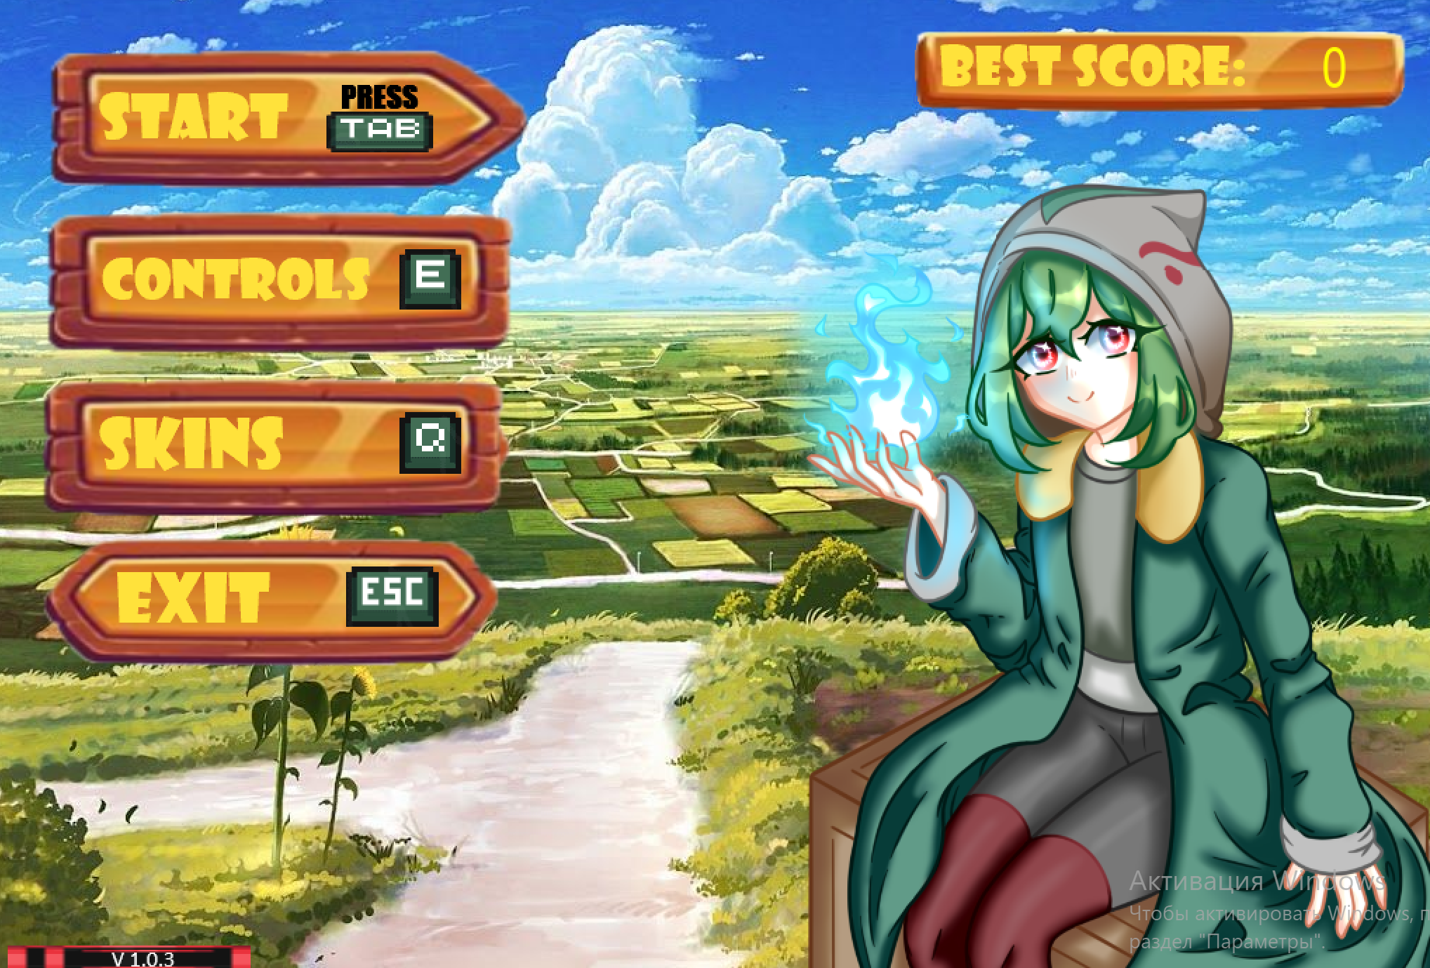

Controls screen:

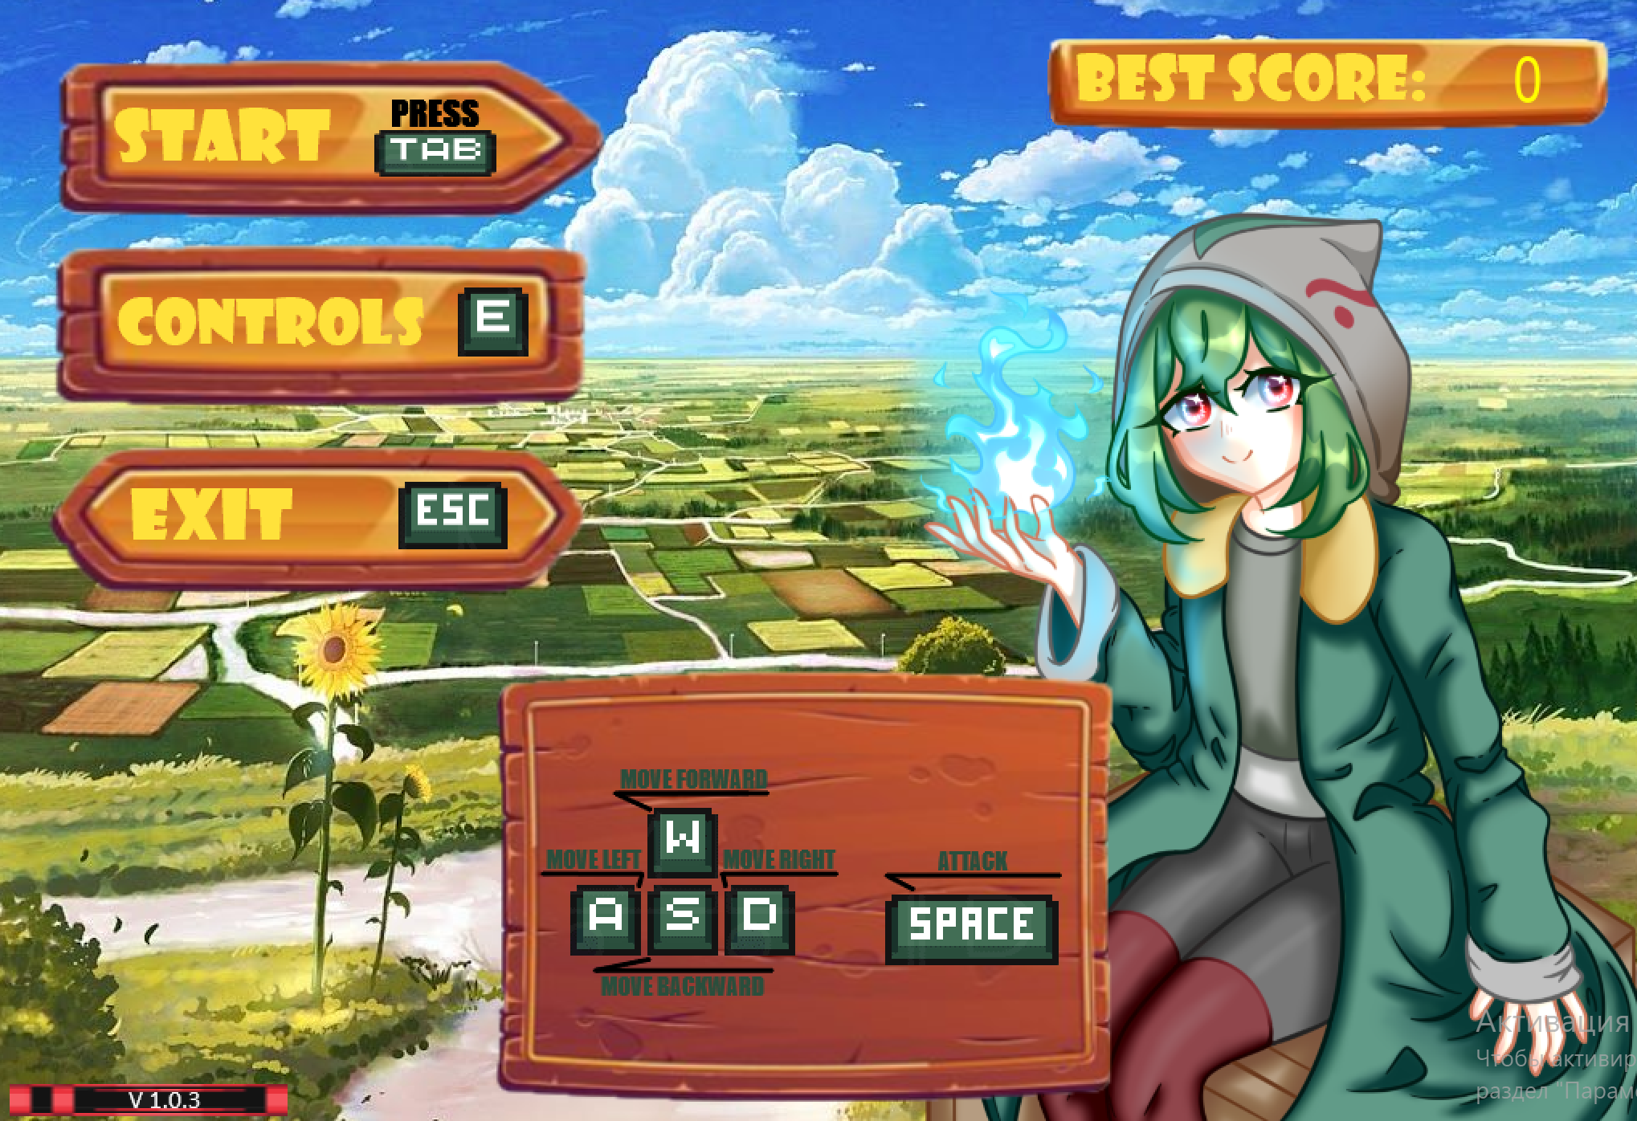

Skin settings screen:

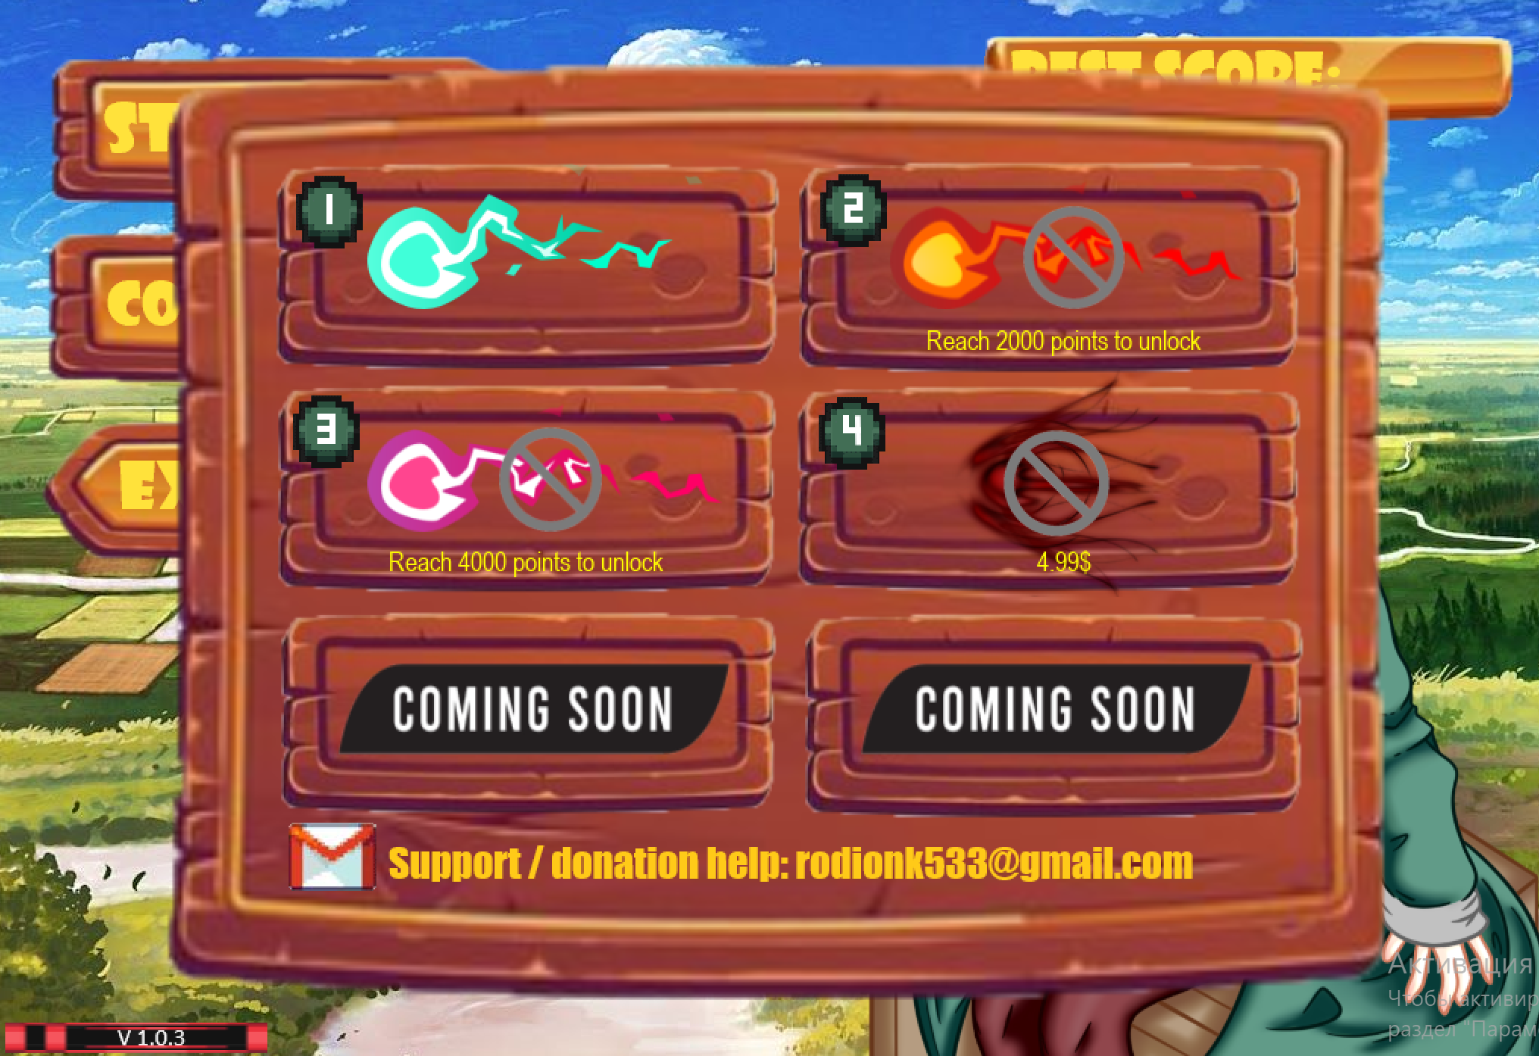

Game screen:

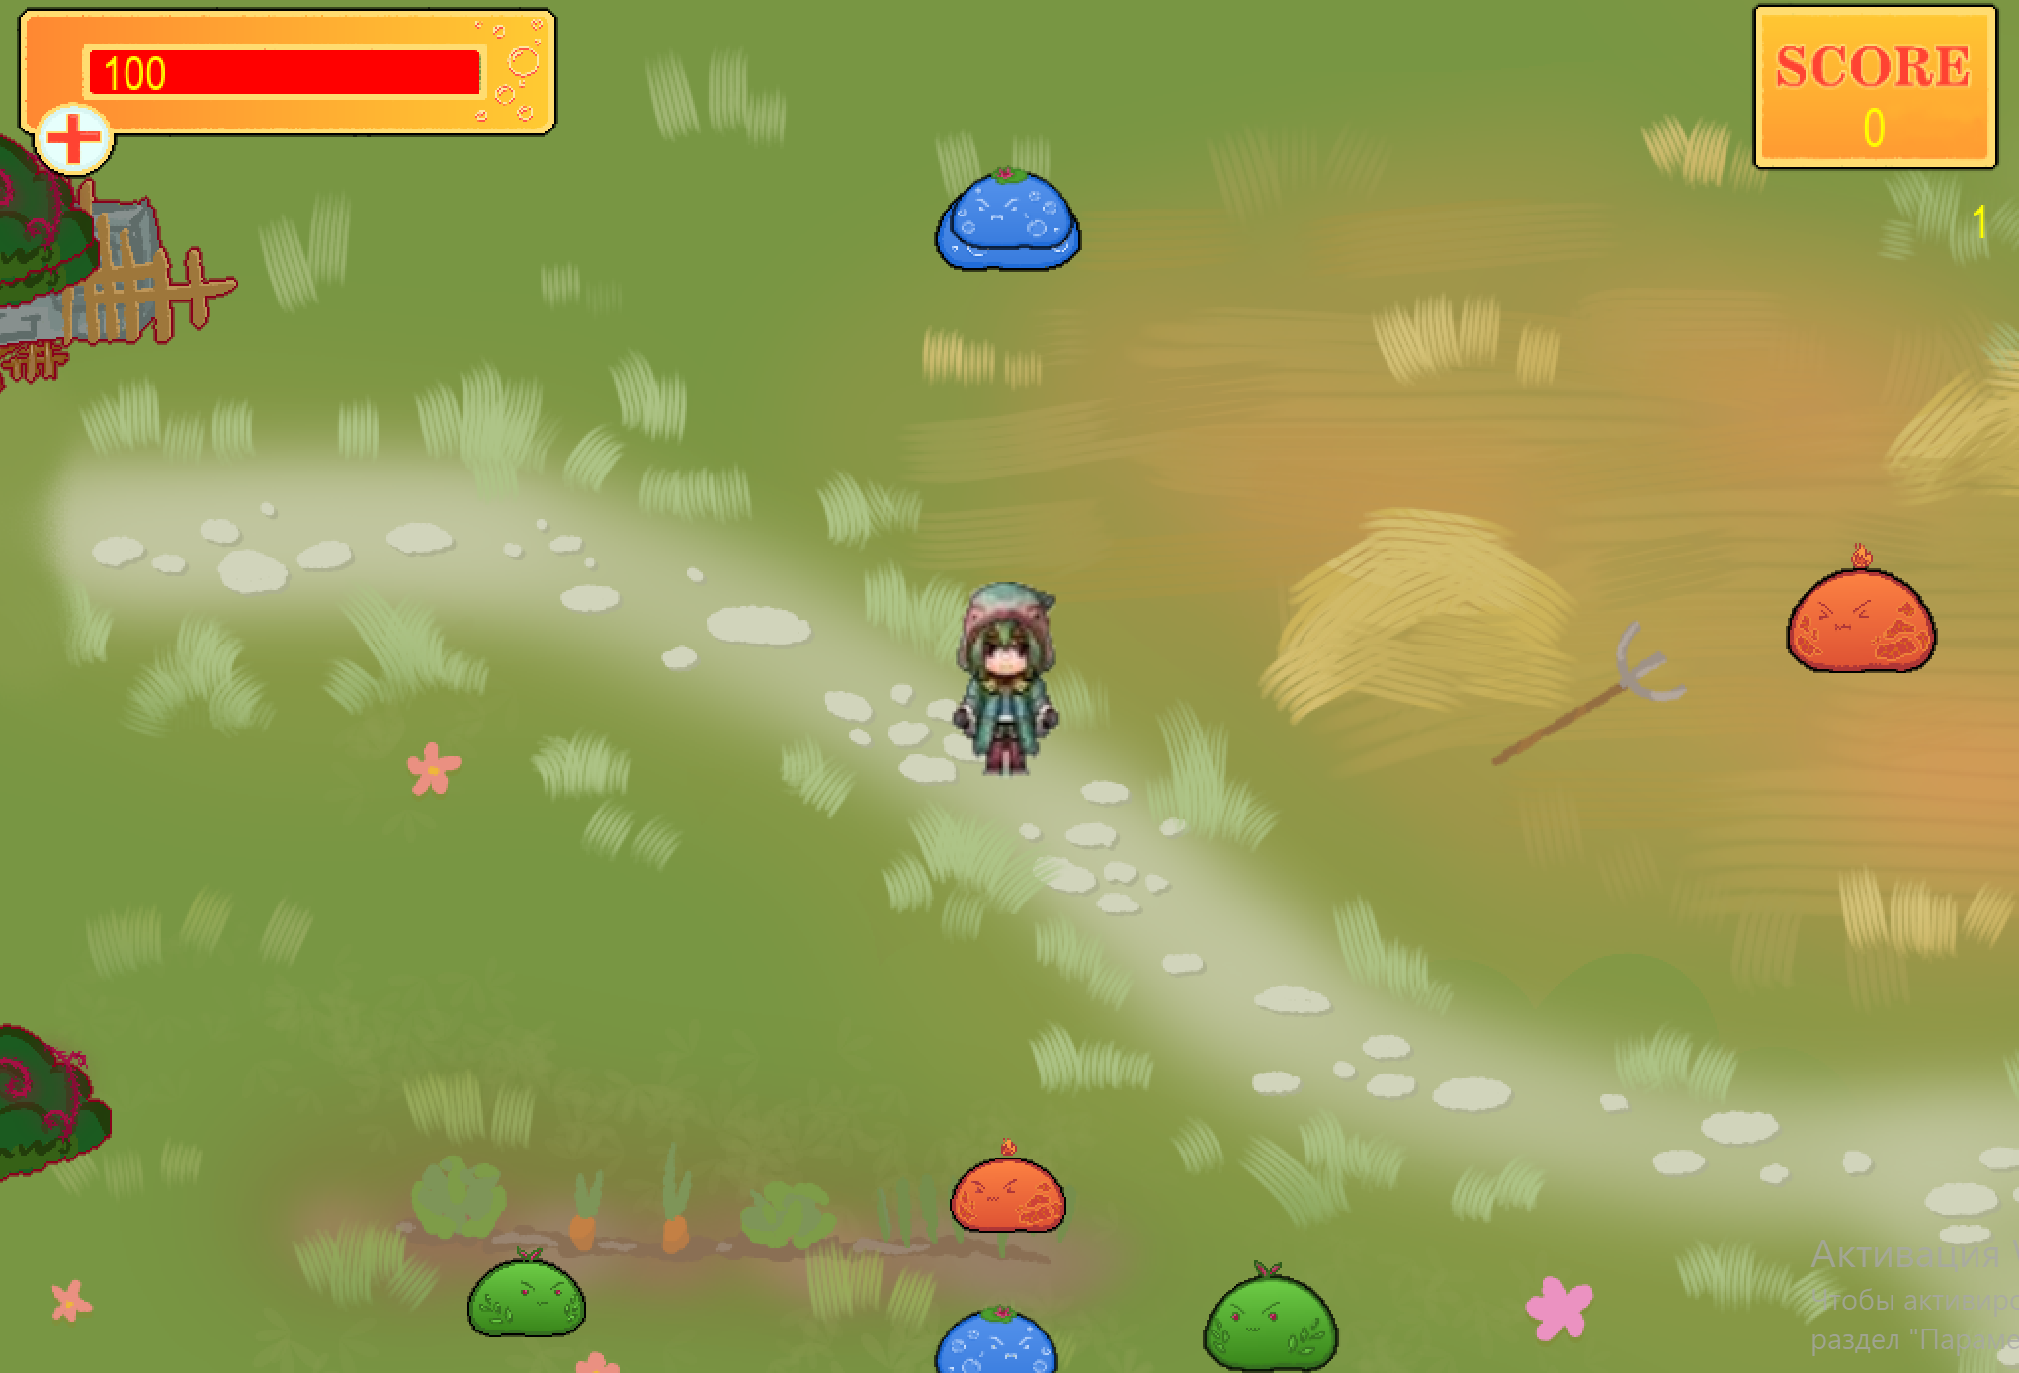

**Troubleshooting:**

1. If the game won't start, restart your computer.
2. If that doesn't fix the problem, reinstall the executable or update the python compiler from official website or from windows store (prefered).

If that doesn't fix the problem again, install pygame library on your computer: right click on Windows button on your computer and open Windows PowerShell 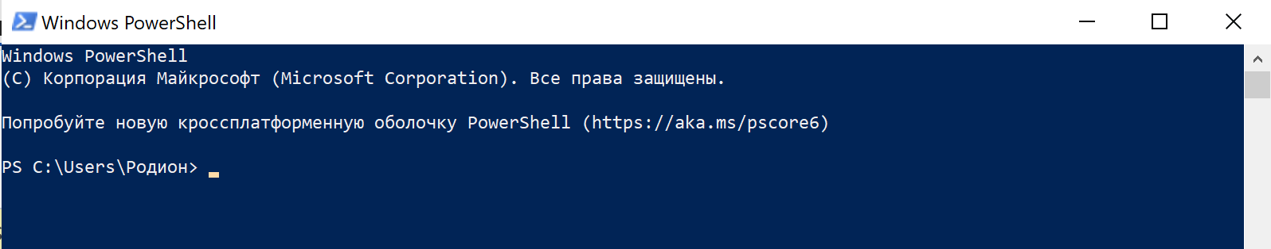Then type “pip install pygame”, wait for installation and after that restart your computer.

1. If an error occurs: “something”_img = pygame.image.load(os.path.join(

FileNotFoundError: No such file or directory.

Check the integrity of the texture and sound folders – “img” and “snd”. Or reinstall them.

1. If an error occurs: ValueError: invalid literal for int() with base 10: “”

Open the “text.txt” file. Delete all data and type 0. Then save and close the file.

1. If the game doesn't work, please contact support service – [rodion.korshunov.04@mail.ru](mailto:rodion.korshunov.04@mail.ru) or [rodionk533@gmail.com](mailto:rodionk533@gmail.com)